Create Django Projec

- Create virtual environment

>> mkdir Project Sample
>> cd Project Sample

>> python -m venv myvenv

- Run myvenv
>> myvenv\Scripts\activate

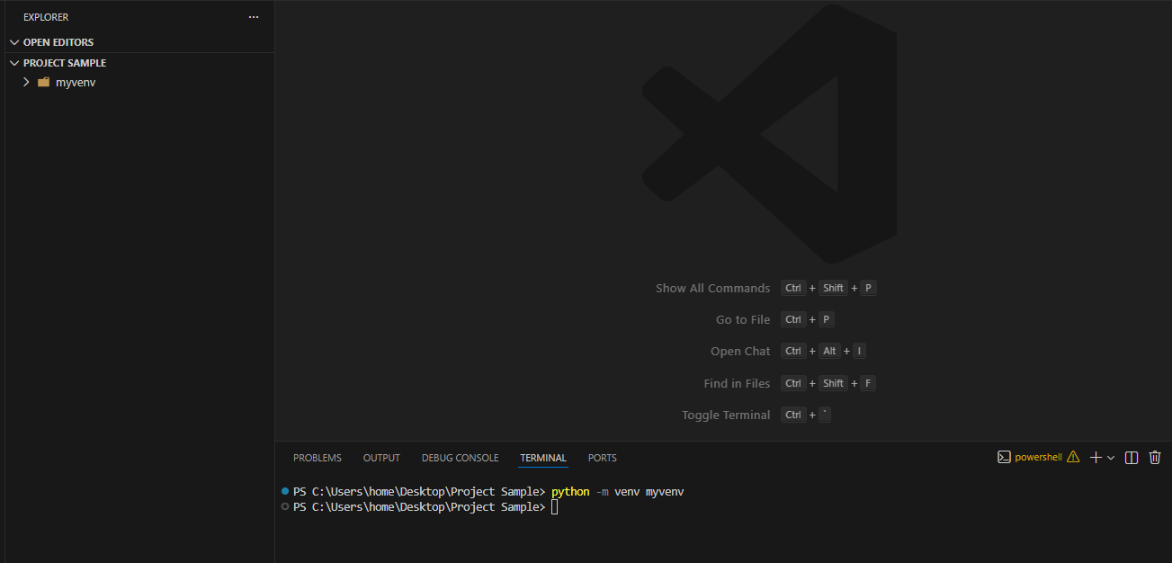

The command line show be in side the (venv):

(myvenv) PS C:\Users\home\Desktop\Project Sample>>

“Start from this we will use (myvenv) “

- Install Django and update

>>python -m pip install --upgrade pip
>>pip install Django

- Check if the Django installed or not

>> pip show Django
Name: Django
Version: 5.2.8

- Create project name: my_site
>>django-admin startproject my_site .

Must have . and this end !

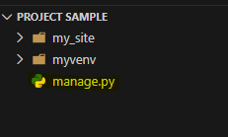

It must have manage.py (this is the heart of running)

- Create App in site the project

>> python manage.py startapp blog
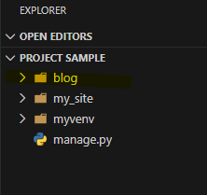

- Register the app and templates directory
- Open my_site/settings.py and update:

Need add three location : register ‘blog’, add template and css

Take a look at white color :

